PROJECT NAME

***ANALYZING THE PERFORMANCE & EFFICIENCY OF THE RADISSION HOTELS USING DATA VISUALIZATION TECHNIQUES***

TEAM MEMBERS

1. A MOHASEEN ASMA SULTHANA
2. S SNEKA
3. B NIVETHA
4. R VAHINI
5. C VISHALINI

PROJECT REPORT

1. INTRODUCTION
   1. OVERVIEW:

*Radisson company has more five stars hotels across the India. They have been the hospitality manner among the people for past 100 years .Recently its shares are decreasing. And the strategic moves from other competitors and ineffective decision –making in management, So the Hotel losing its making share and revenue in the Luxury/Bussiness hotels category. We are creating a ideas and process to provide them insights to make better business decisions.*

* 1. PURPOSE :

The problem is " The Radisson Hotel's market shares are drowning .In the growth of the competitors and ineffective decision making are the main reason to the loss". So now the Managing Director needs good ideas to improve his hotel shares and Bussiness.

1. Problem Definition & Design Thinking

2.1EmpathyMap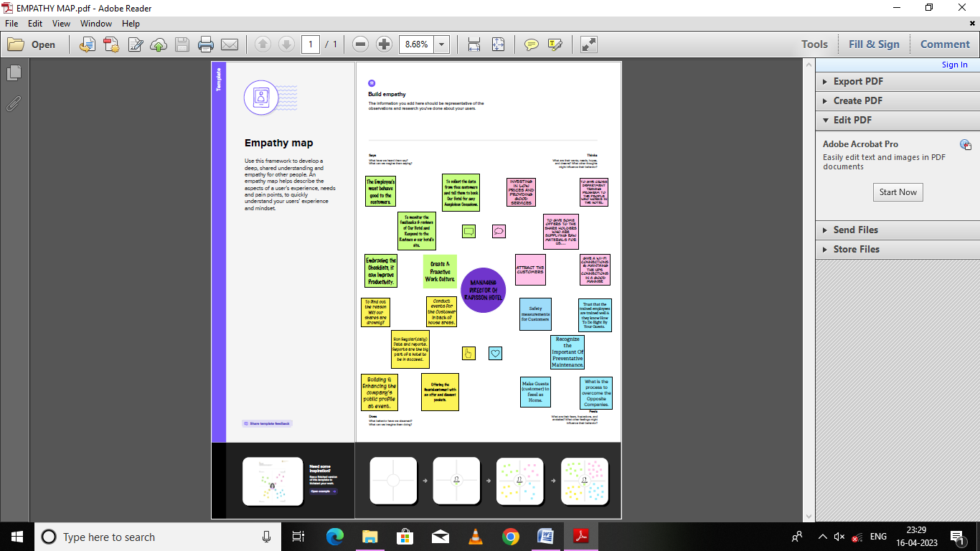

2.2 Ideation & Brainstorming Map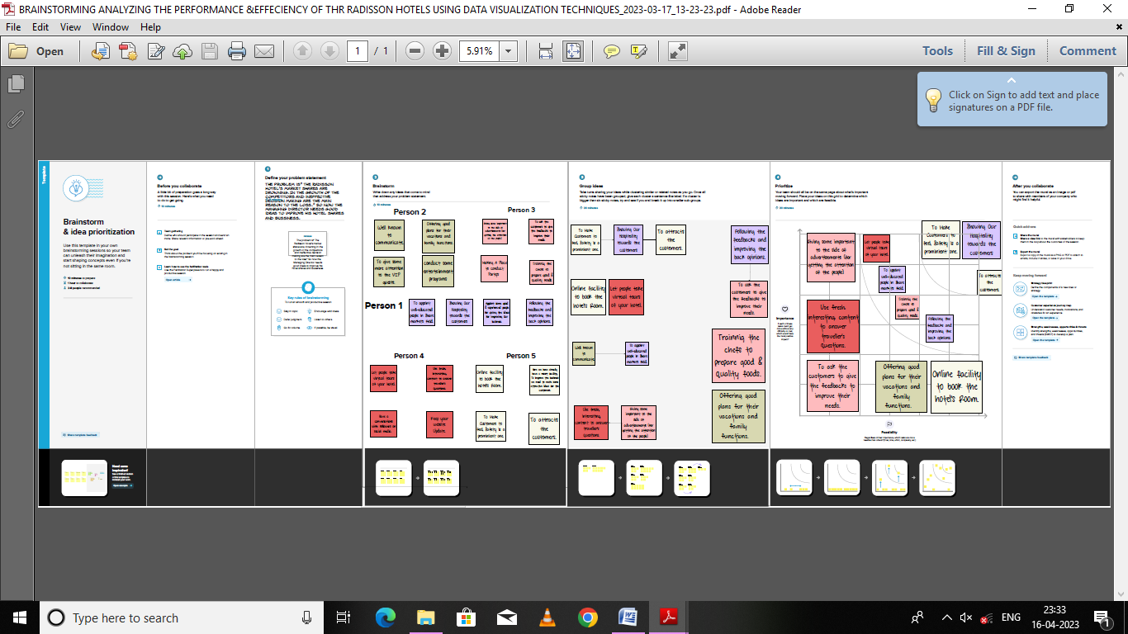

1. Result 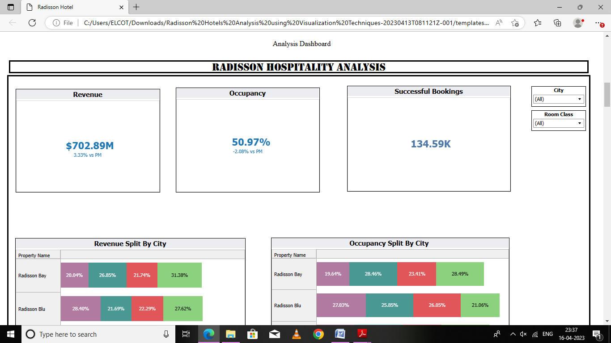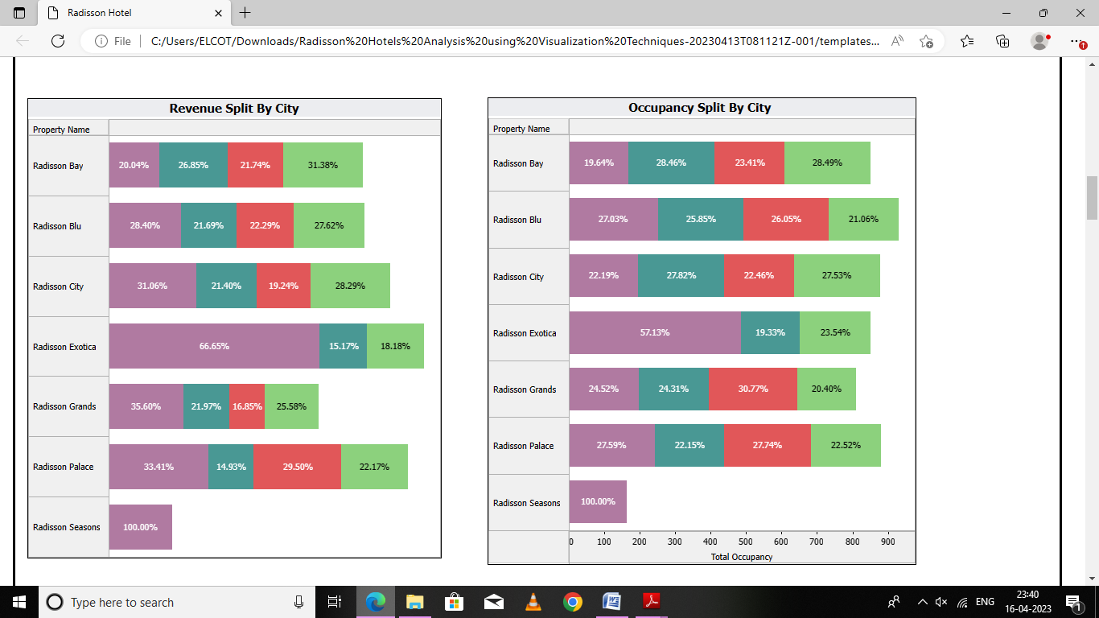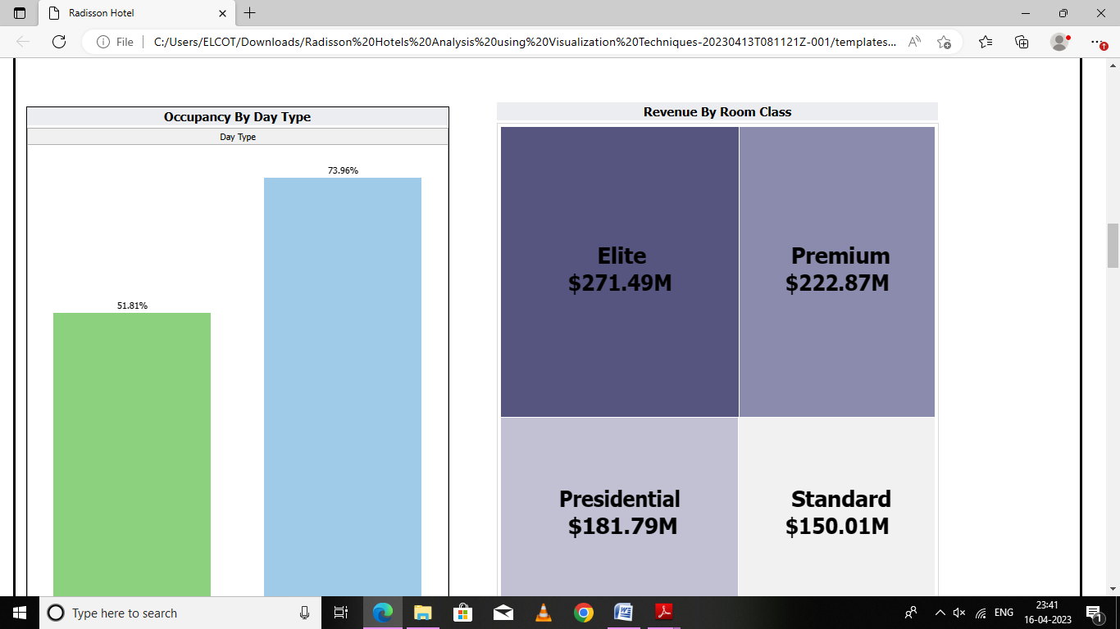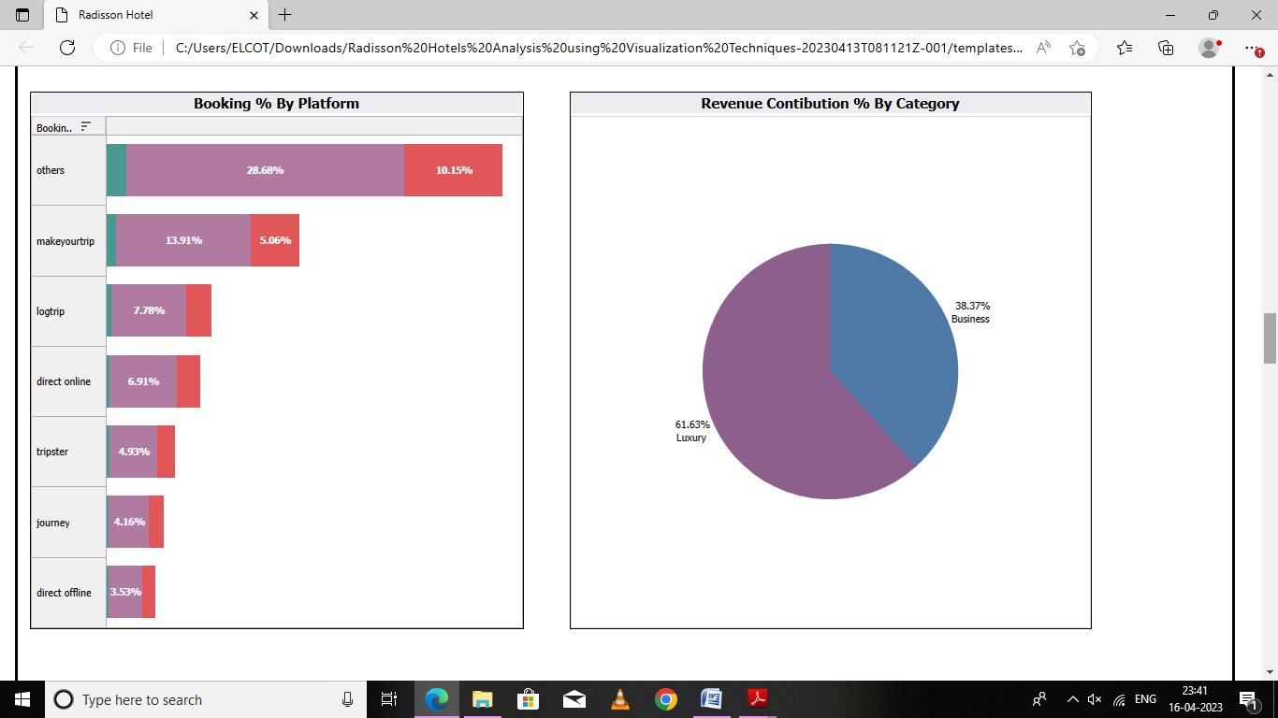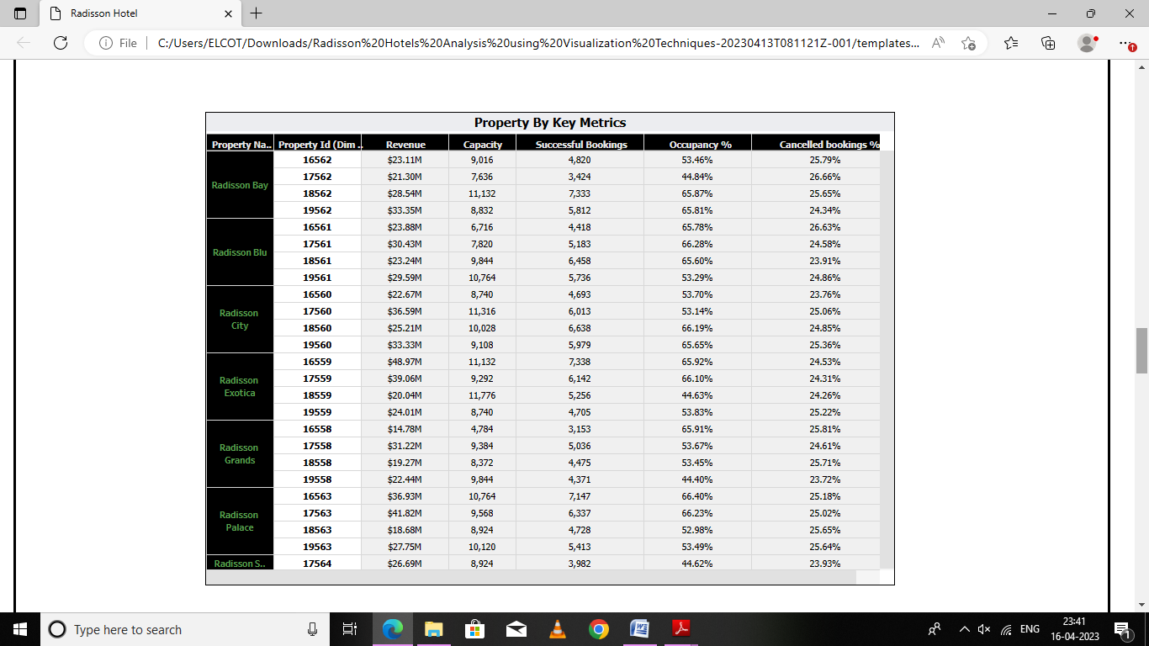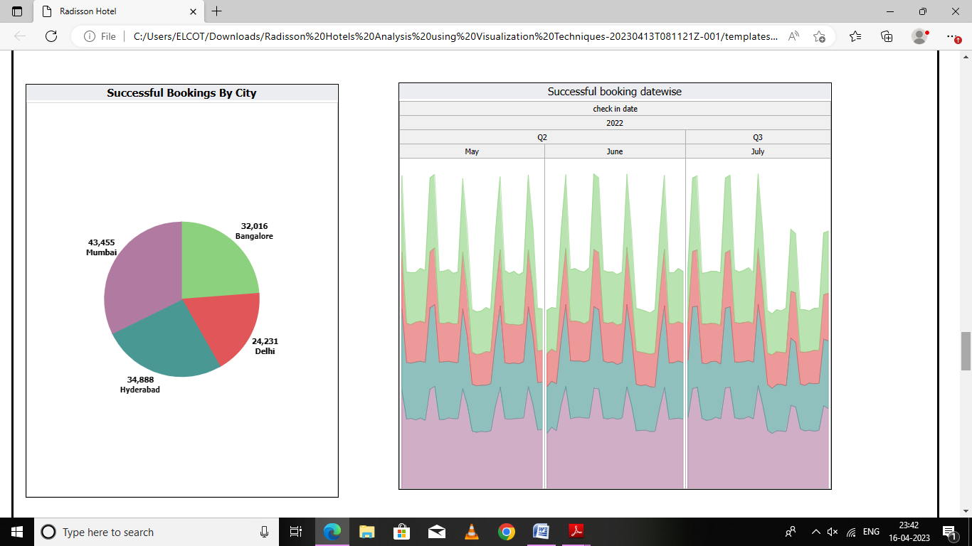

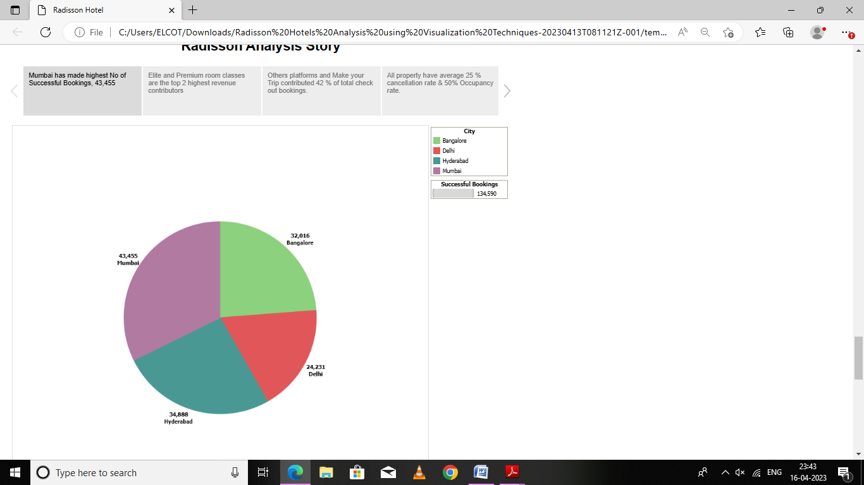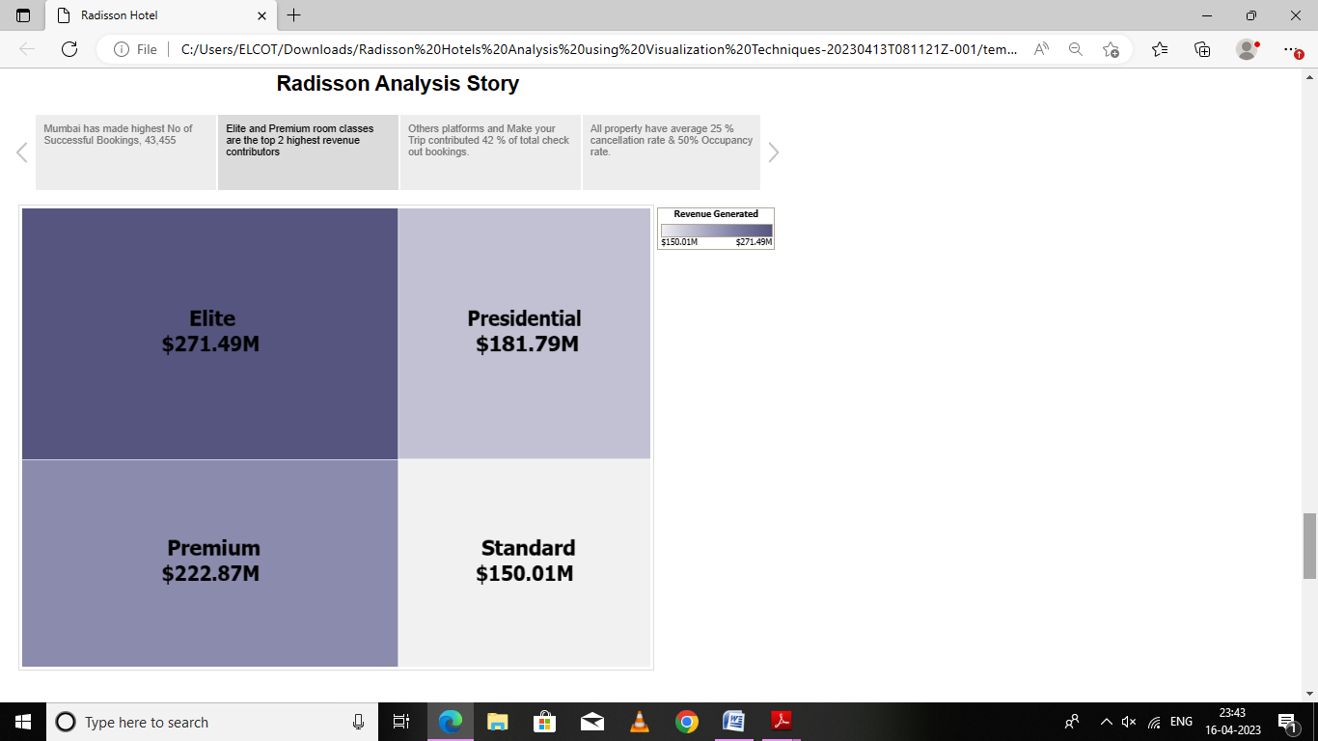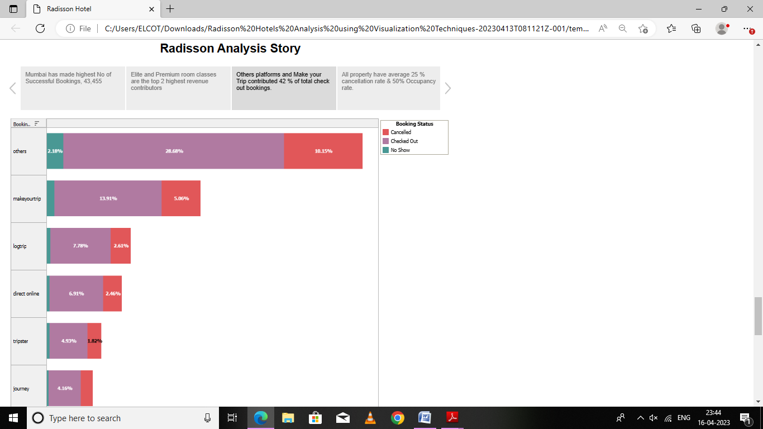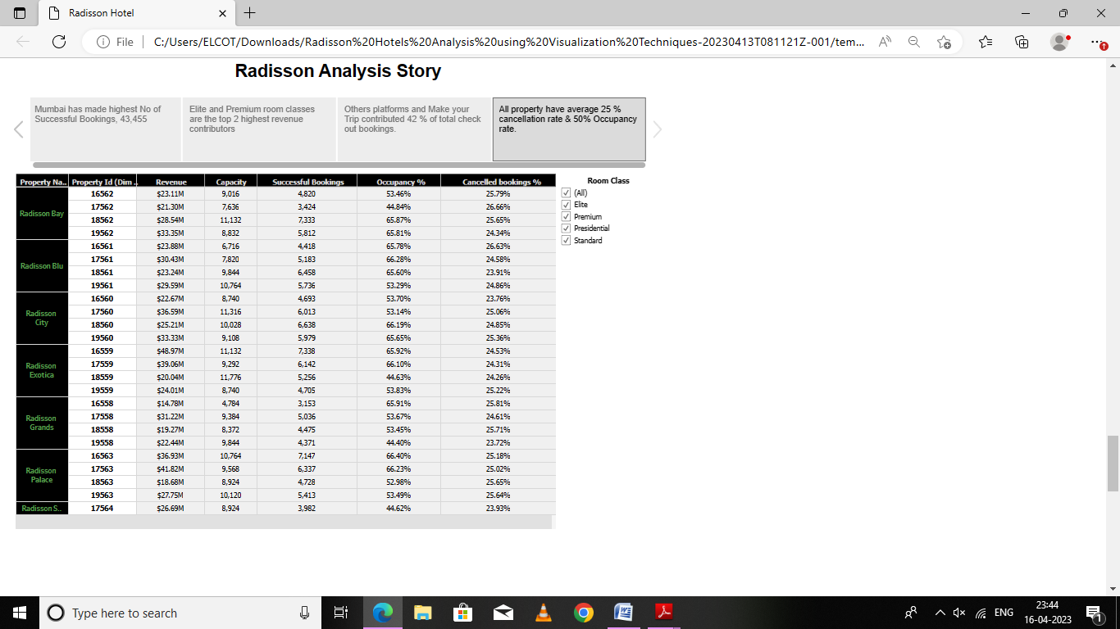

1. Advantages & Disadvantages

*Radission hotels can Improve safety of customers & can get customer or guest satisfaction, and hygiene food. Business*

*Tthe company can identify areas for improvement and take steps to enhance the customer experience, and increase customer satisfaction and loyalty. Improve its brand reputation, which can lead to increased customer loyalty and repeat business.*

1. Applications

*The requirements for analyzing the performance and efficiency of Radisson Hotels include identifying KPIs, comparing performance across different hotels, identifying patterns and trends over time, identifying affecting factors, creating interactive dashboards and reports, identifying areas for improvement, making data driven decisions, comparing to industry average and creating forecasting models for future performance. The ultimate goal is to gain insights and improve performance through data visualization techniques.*

1. Conclusion

*We have sort out the problem and analysis the reason that how they shares are decreasing .*

1. Future Scope

*In future The Radission Hotel will be the Top Most Peoples favour Hotel. It will inaugurate more games and parties for the customers.*

*It may use the new versions in the hotel industries.*

1. Appendix

Source code : ///C:/Users/ELCOT/Downloads/Radisson%20Hotels%20Analysis%20using%20Visualization%20Techniques-20230413T133533Z-001/ASMA/templates/index.html